Introduction to SDL
and using Third Party Libraries
in your Programs

Table of Contents
Third Party Libraries 1
SDL 1
Getting Started 2
1. Download the SDL library 2
2. Create a new project 2
3. Set up the Project Build Options 3
4. Super basic SDL program 3
SDL Super Basics 4
1. Creating a window 4
The result! 5
Full source code 6
2. Loading and drawing images 7
Now what? 7

Third Party Libraries
A library is essentially code that somebody has written, intended for reuse. They are generally precompiled into .dll or other library files (.a, .so, …), and your program can link to these libraries in order to use the functionality within them.
Often, libraries will also have homepages where you can find in-depth documentation.
Libraries can be for anything – from text to speech, to UI, to game development.

SDL
http://libsdl.org/index.php
SDL (Simple DirectMedia Layer) is a C library that will handle things like input, graphics, audio, threading, timers, and more for you. SDL has been popular in the past for creating cross-platform games, and many games for Linux use SDL.
The 2.0 version of SDL adds support for building for mobile, so not only can you build for Windows, OSX, and Linux, but also for Android and iOS.

Getting Started
For this tutorial, the assumed operating system is Windows, and the assumed IDE is Code::Blocks. Linking in Code::Blocks on Linux is similar – it’s mostly about locating the library files (.dll, .a, or .so), and pointing the search directories to the appropriate folders.

1. Download the SDL library
Go to http://libsdl.org/download-2.0.php – scroll to the Development Libraries, and under Windows download the MinGW version (SDL2-devel-2.0.4-mingw.tar.gz (MinGW 32/64-bit) – Code::Blocks uses MinGW as its compiler.
If you don’t have a tool that can decompress .tar.gz files, you should check out 7-Zip:
http://www.7-zip.org/
Decompress the library into a folder on your hard-drive. I’ve stored it at:
C:\Libraries\SDL2-devel-2.0.4-mingw
Within the folder, there should be directories such as docs, include, lib, and more. There should also be a folder named i686-w64-mingw32 … This folder contains the libraries that we need for our program.

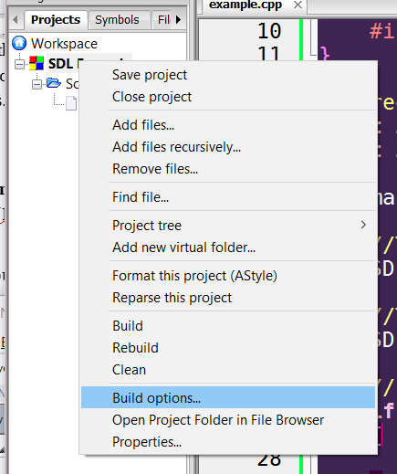
2. Create a new project
In Code::Blocks, create a new Empty Project, and add a source file to it. In the project pane, you will want to right-click on your project and select
Build Options…
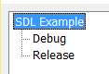
In the Project build options window, make sure to select your project’s name, instead of Debug or Release.

This is so that your changes will affect both Debug and Release, instead of just one or the other.

3. Set up the Project Build Options
First, select the Linker settings tab. There are two sections: Link libraries and Other linker options.
- In the Link libraries section, click the Add button. Navigate to the
i686-w64-mingw32\lib\ path. Select both libSDL2main.a and libSDL2.a libraries (you can ctrl+click to select multiple). Click OK.
- In the Other linker options section, add the following lines:
-lmingw32
-lSDL2main
-lSDL2
Note that each of these begin with a dash, then a lower-case L (for library).

Next, go to the Search directories tab.
- Select the Compiler sub-tab. Click on the Add button. Navigate to
i686-w64-mingw32\include\SDL2 and use this directory
(you’re selecting a directory, not a file).
- Select the Linker sub-tab. Click on the Add button. Navigate to
i686-w64-mingw32\lib and use this directory.
Click OK to leave the project build options.

4. Super basic SDL program
To test to see whether the libraries were successfully linked, write a short program that uses the SDL library and build. If the build is successful and the program opens (and then closes), we should be good to go.  If you’re getting an error about SDL.h not being found, check the path in the Search directories part. Note that you have to have the argc / args parameters of main() otherwise you’ll get a different build error.  Now we can start doing more with SDL.
  #include <SDL.h>
  extern "C"
  {
  #include "SDL.h"
  }
  int main( int argc, char* args[] )
  {
  SDL_Init( SDL_INIT_VIDEO );
  SDL_Quit();
  return 0;
  }

SDL Super Basics

1. Creating a window
Before you can start drawing anything, you need to create a window. This will be different from the terminal that we have normally be writing our programs in – though you can still continue using cout to display information to that terminal.
For now, we are just working within main(), but eventually you should strive to work with clean code, and abstract a lot of this out into other functions or classes.
The SDL_Init function will return a negative value if there is an error, so you should check for a result.
  int result = SDL_Init( SDL_INIT_VIDEO );
  if ( result < 0 )
  {
  cerr << "Error on SDL_Init!"
  << endl << SDL_GetError() << endl;
  return -1;
  }
You will need an object called a SDL_Window that will be initialized to be the window, as well as an SDL_Surface, which will be a surface that we draw to.
  SDL_Window* window = NULL;
  SDL_Surface* screenSurface = NULL;
We will create a Window object with the SDL_CreateWindow function.  http://wiki.libsdl.org/SDL_CreateWindow  SDL_Window* SDL_CreateWindow(  const char* title, int x, int y, int w, int h, Uint32 flags)  You can use  SDL_WINDOWPOS_UNDEFINED  in place of the X, Y coordinates if you’d like.  If window is still NULL after the create function, then there was an error.
  window = SDL_CreateWindow( "PROJECT NAME",
  SDL_WINDOWPOS_UNDEFINED, // x
  SDL_WINDOWPOS_UNDEFINED, // y
  640, 480, SDL_WINDOW_SHOWN );
  if ( window == NULL )
  {
  cerr << "Error on SDL_CreateWindow!"
  << endl << SDL_GetError() << endl;
  return -2;
  }
Next, we will have to create the screen surface that we’re drawing to.
  screenSurface = SDL_GetWindowSurface( window );
We can draw some shapes to the screen as a test…  int SDL_FillRect(  SDL_Surface* dst,  const SDL_Rect* rect, Uint32 color)
  // Background
  SDL_Rect fullScreen = { 0, 0, 640, 480 };
  SDL_FillRect( screenSurface,
  &fullScreen, // x,y/w,h
  SDL_MapRGB( screenSurface->format,
  0x7B, 0xBF, 0xFF ) ); // r,g,b
  // Smaller box
  SDL_Rect subRegion = { 20, 20, 150, 200 };
  SDL_FillRect( screenSurface,
  &subRegion, // x,y/w,h
  SDL_MapRGB( screenSurface->format,
  0x5C, 0x09, 0x9C ) ); // r,g,b
Then we update the window.
  SDL_UpdateWindowSurface( window );
We don’t have a game loop set up yet, so let’s pause the program for a few seconds (so we can see it) before it quits.
  SDL_Delay( 2000 );
Finally, we must remember to use SDL_DestroyWindow at the end, then SDL_Quit.
  SDL_DestroyWindow( window );
  SDL_Quit();
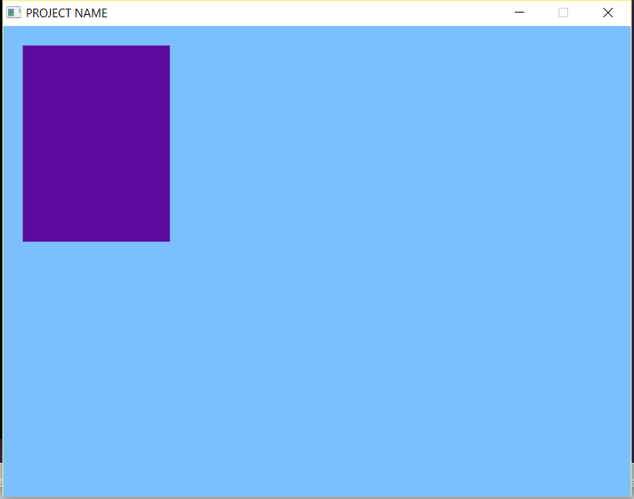

The result!
The result should be a window with some rectangles:
The first step towards graphical programming!
The full source is on the next page.

Full source code
Page 1 | Page 2
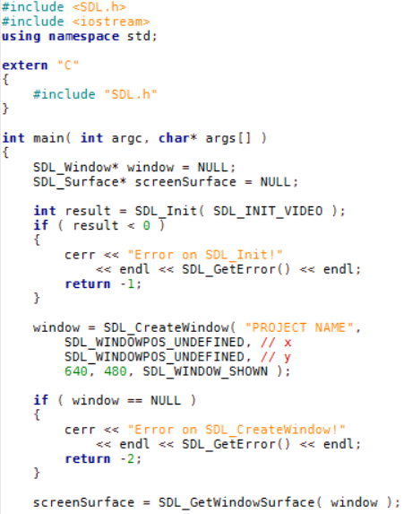 | 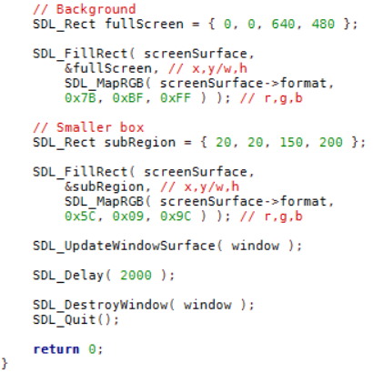

2. Loading and drawing images
SDL_Surface objects are where images are stored. We can draw to a surface (like the window’s surface in the above example), or we can load images to a surface.
After we draw the rectangles to the screen and before we call SDL_UpdateWindow, let’s create and load an image:
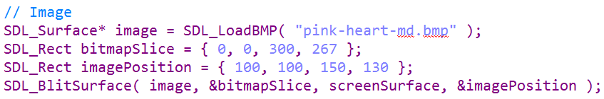
When we create a new SDL_Surface*, we will want to make sure to free it at the end of the program:
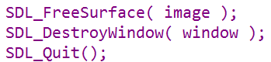

The result should be something like this:
This is only drawing bitmaps (.bmp), but we can include additional SDL libraries in order to load in other image types, like pngs.

Now what?
There are a lot of tutorials over SDL available at the Lazyfoo webpage:
http://lazyfoo.net/tutorials/SDL/index.php

